Free
English Conversation
Practice!

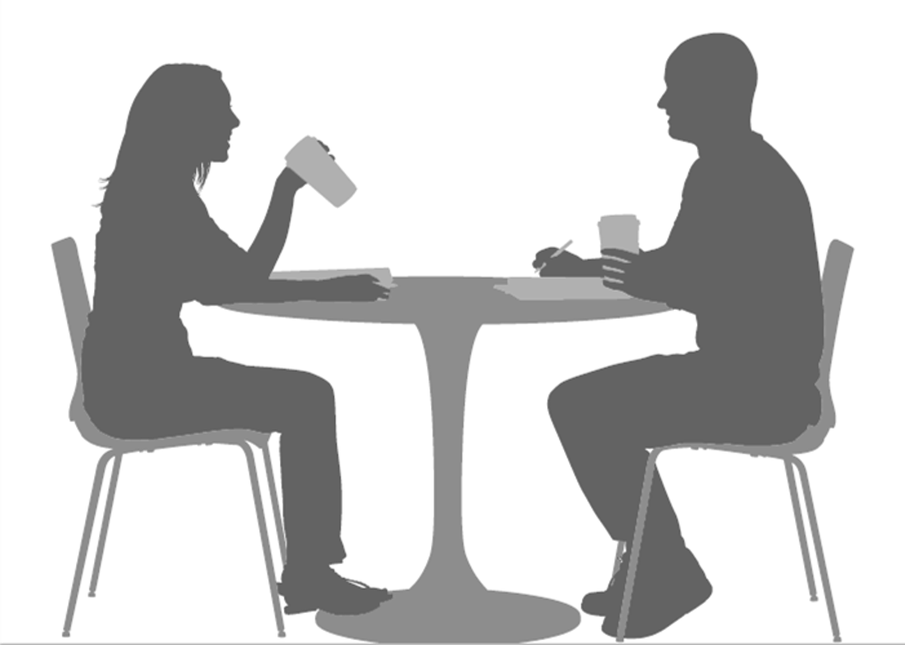
- One-to–one conversation - 45 minute session
- next sessions start in February 2018
- all language backgrounds welcome
- discussion text from book of Luke
- hosted by Central Christian Campus Center
- loacted at 2123 Central Avenue (by UC Library)
Questions? Talk to us!
Please call or email:
Name
XXX—XXX—XXXX
friendspeak@central.com

