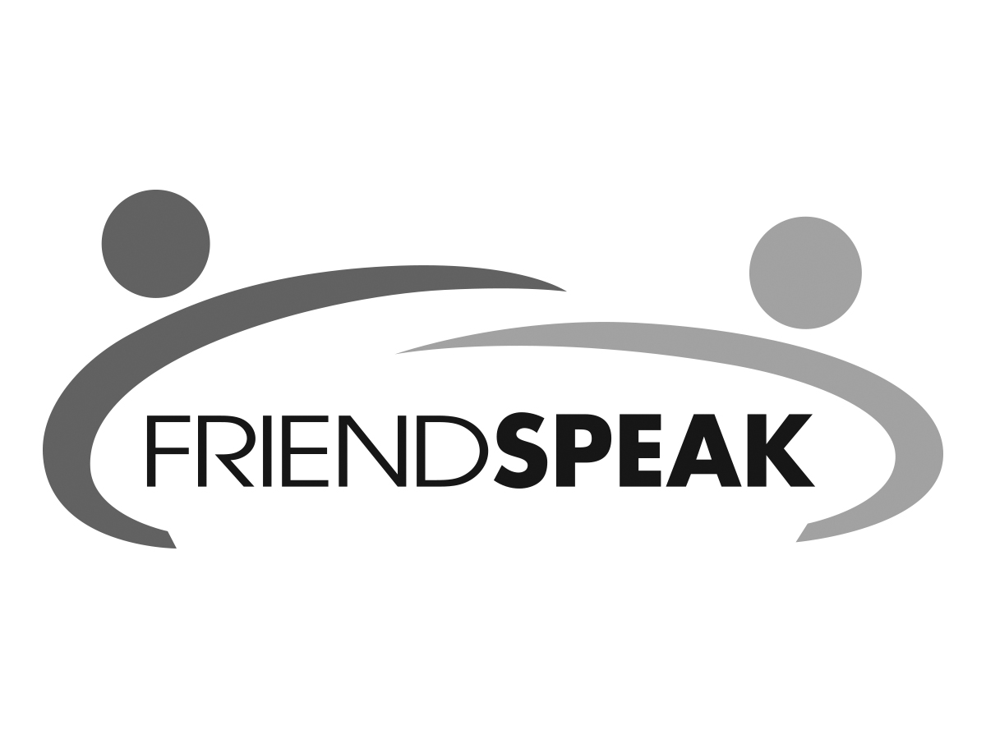

Free English Practice Sessions

***Improve your English through conversation.***





For more information:

please call Name: 817-555-XXXX

or email: helloFS@email.net